|  |
| --- |
| ***A Mini Project Synopsis on***  **ONLINE CLOTHING STORE**  **S.E. - I.T Engineering**  **Submitted By**  **Ashmina Dangat ( 20104052 )**  **Sakshi Gunjal ( 20104106 )**  **Neha Chaudhary ( 20104134 )**  **Kritika Donde ( 20104102 )**    **Under The Guidance Of**  **Prof. Manasi Choche**    **DEPARTMENT OF INFORMATION TECHNOLOGY**  A.P. SHAH INSTITUTE OF TECHNOLOGY  G.B. Road, Kasarvadavali, Thane (W), Mumbai400615  UNIVERSITY OF MUMBAI  Academic year : 2021 – 22  **CERTIFICATE**  This to certify that the Mini Project report on Online Clothing Storehas been submitted by Neha Chaudhary (20104134), Kritika Donde (20104102) Ashmina Dangat (20104052) and Sakshi Gunjal (20104106) who are a Bonafede students of A. P. Shah Institute of Technology, Thane, Mumbai, as a partial fulfilment of the requirement for the degree in Information Technology, during the academic year 2021-2022in the satisfactory manner as per the curriculum laid down by University of Mumbai.  Guide: Prof. Mansi Choche  Prof. Kiran Deshpande Dr. Uttam D.Kolekar  Head Department of Information Technology Principal  External Examiner(s)  1.  2.  Place: A.P Shah Institute of Technology, Thane |

**TABLE OF CONTENTS**

1. Introduction……………………………………………………………..1
   1. Purpose…………………………………………………………..1
   2. Objectives………………………………………………………..2
   3. Scope………………………………………………………...…..2
2. Problem Definition……………………………………………….....…..3
3. Proposed System…………………………………………………….….4
   1. Features And Functionality……………………………………...4
4. Project Outcomes……………………………………………………….5
5. Software Requirements…………………………………….…………...6
6. Project Design………………………………………………..………....7
7. Project scheduling…………………………………………………… .14
8. Conclusion…………………………………………………………….16

# Chapter 1

**Introduction**

Our online store enables the customer to browse the firm's range of products and services, view photos or images of the products, along with information about the product specifications, features and prices. Also the availability is 24-7 unlike the physical retail store which are generally available in specific time. Online stores usually enable shoppers to use "search" features to find specific models, brands or items. Online customers must have access to the Internet and a valid method of payment in order to complete a transaction, such as a credit card,  debit card, or a service such as Cashfree.

* 1. **Purpose:**

Shopping has long been considered a recreational activity by many. Shopping online is no exception. The goal of this application is to develop a web based interface for online retailers. The system would be easy to use and hence make the shopping experience pleasant for the users. The purpose of this application is

* To develop an easy to use web based interface where users can search for products, view a complete description of the products and order the products.
* Enables the customer to view the firm's range of products and services, view photos or images of the products, along with information about the product specifications, features and prices.
* You will find affordable and excellent prices available online since you get products directly from the seller without involving any other second party.

**1.2 Objectives:**

* To build an application program to reduce the manual work of customer and seller.
* To develop a user-friendly portal that can accessible anytime and anywhere.
* To build an efficient shopping site.
* To build a system that is useful for both customer as well as the admin.
* To manage the details of Clothes, Payment, and Adding new customer to the secured databases.
* To come up with an arrangement that makes overall handling of data easier and flexible.
* To build at administrative end and thus only the administrator is guaranteed the access.
  1. **Scope**

It may help collecting perfect management in details. In a very short time, the collection will be obvious, simple and sensible. It also helps in all current works relative to Online Clothing Store. It will also reduced the cost of management and the process will go on smoothly.

Our project aims at Business process automation, i.e., we have tried to computerize various processes of Online Clothing Store.

• In computer system the person has to fill the various forms & number of copies of the forms can be easily generated at a time.

• Saves time as the process is easily accessible anytime and anywhere.

• To assist the staff in capturing the effort spent on their respective working areas.

• To utilize resources in an efficient manner by increasing their productivity through automation.

• The system generates types of information that can be used for various purposes.

• It satisfies the user requirement.

• Have a good user interface.

# Chapter 2

**Problem Definition**

This project aims to develop online clothing for customers with the goal that it is very easy to shop for your loved things from an extensive number of online clothing sites available on the web. With the help of this, you can carry out online clothing from your home. Here is no compelling reason to go to crowded stores or shopping centres during festival seasons. You simply require a PC or a laptop and one important payment sending option to shop online. To get to this online clothing mart all the customers will need to have an email and password to log in and proceed with their shopping. The login credentials for an online shopping system are under high security and nobody will have the capacity to crack it easily. Upon successful login, the customers can purchase a wide range of things such as clothes and accessories. can be dispatched using the online clothing mart. And of course, you will get your requested ordered items at your doorstep. It is simple. You will pick your favourite items from a variety of online clothing sites looking at cost and quality. No need to go to physical shops with this you will have more time to spend with your family. It Just needs a computer and payment making options like net banking, credit card, debit card or Cash on Delivery. Almost a wide range of clothes can be brought through online clothing mart. It is extremely secure.

# Chapter 3

**3.1 Proposed System:**

The aim of proposed system is to develop a system of improved facilities. The proposed system can overcome all the limitations of the existing system. The system provides proper security and reduces the manual work. The following are the things which we have included in our system:

* Security of data.
* Ensure data accuracies.
* Minimize manual data entry.
* Minimum time needed for the various processing.
* Greater efficiency.
* Better service.
* User friendliness and interactive.
* Minimum time required.

**3.2 Features And Functionality:**

* Registration is quite simple, user has to using e-mail ID, name, phone number, username and password.
* User friendly website.
* Detailed product description.
* Various categories for men and women.
* Includes all types of payment modes
* Easy to manage admin database.
* There are different options to save products like add to cart or wish list.
* Browse products.

**Chapter 4**

**Project Outcome:**

The main object of the project was to save time and energy of customers in shopping which is fulfilled by the Online Clothing store. The web-application is quite user-friendly and easy to use. Customers can get variety due to proper segregation of clothes in each section. Also the customer can satisfy their desire of window shopping without a need to register or login.

* Anyone can login in the website after registration.
* User can search for products available for both male and female
* User can have a detailed information about the product and sizes available
* User can make the payment according to their convenience
* Admin can also control the product availability with the help of this sytsem.
* Maintain a secured web – application for the customers.

# Chapter 5

**Software Requirements:**

* **Front End** : PyQt5 designer
* **Back End** : MySQL Workbench
* **Integrated Development Environment (IDE)**: Vs code.
* **Platform** : Windows 11

# Chapter 6

**Project Design :**

In this phase, a logical system is built which fulfils the given requirements. Design phase of software development deals with transforming the client’s requirements into a logically working system. Normally, design is performed in the following in the following two steps:

1. **Primary Design Phase:**

In this phase, the system is designed at block level. The blocks are created on the basis of analysis done in the problem identification phase. Different blocks are created for different functions emphasis is put on minimising the information flow between blocks. Thus, all activities which require more interaction are kept in one block.

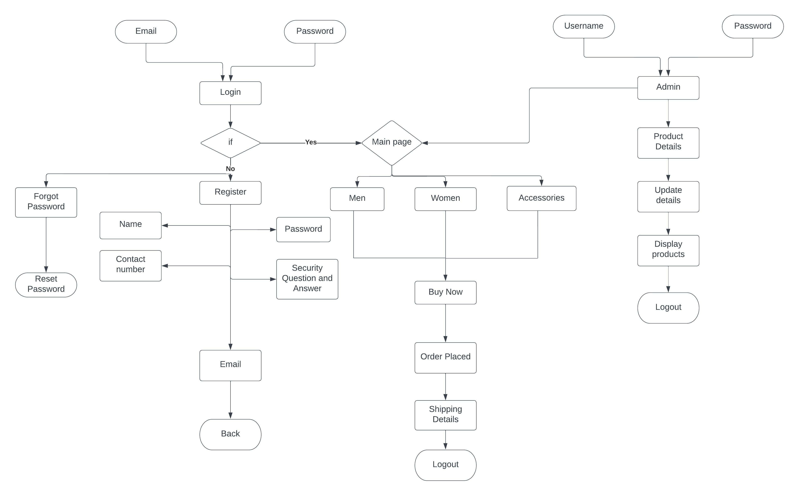

6.1 System flow chart

The flow chart gives you the basic idea of the project. Here the main page is connected to the admin where you can login and can access the insert, update and view options while the other part of main page is connected to Customer page where they can view the product and purchase it.

1. **Secondary Design Phase:**

In the secondary phase the detailed design of every block is performed.

**General tasks involved in the design process are the following**:

* Design various blocks for overall system processes.
* Design smaller, compact and workable modules in each block.
* Design various database structures.
* Specify details of programs to achieve desired functionality.
* Design the form of inputs, and outputs of the system.
* Perform documentation of the design.
* System reviews.

**6.1 User Interface Design**

User Interface Design is concerned with the dialogue between a user and the computer. It is concerned with everything from starting the system or logging into the system to the eventually presentation of desired inputs and outputs. The overall flow of screens and messages is called a dialogue.

**The following steps are various guidelines for User Interface Design:**

* The system user should always be aware of what to do next.
* The screen should be formatted so that various types of information, instructions and messages always appear in the same general display area.
* Message, instructions or information should be displayed long enough to allow the system user to read them.
* Use display attributes sparingly.
* Default values for fields and answers to be entered by the user should be specified.
* A user should not be allowed to proceed without correcting an error.
* The system user should never get an operating system message or fatal error.

**Main Page :**  Here the customer can view the online store by clicking on men or women section while admin can access admin part by clicking admin login.

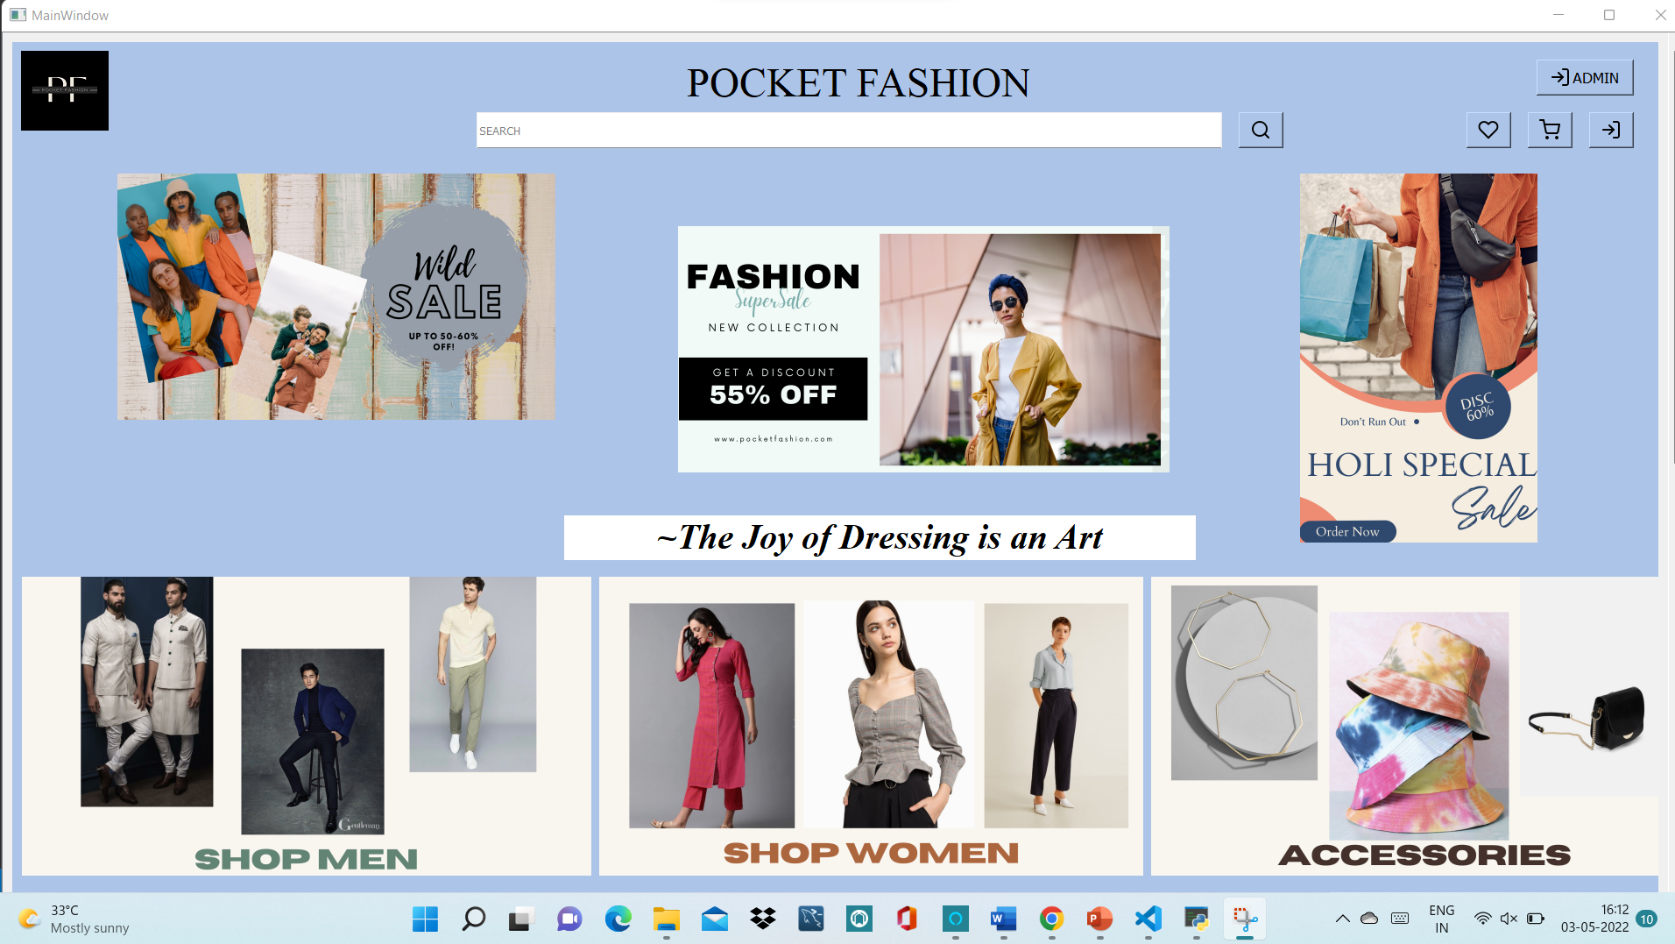

6.1.1. Main page of Online store.

**Admin dashboard:-**

1. **Create product** : Here the Admin can create products

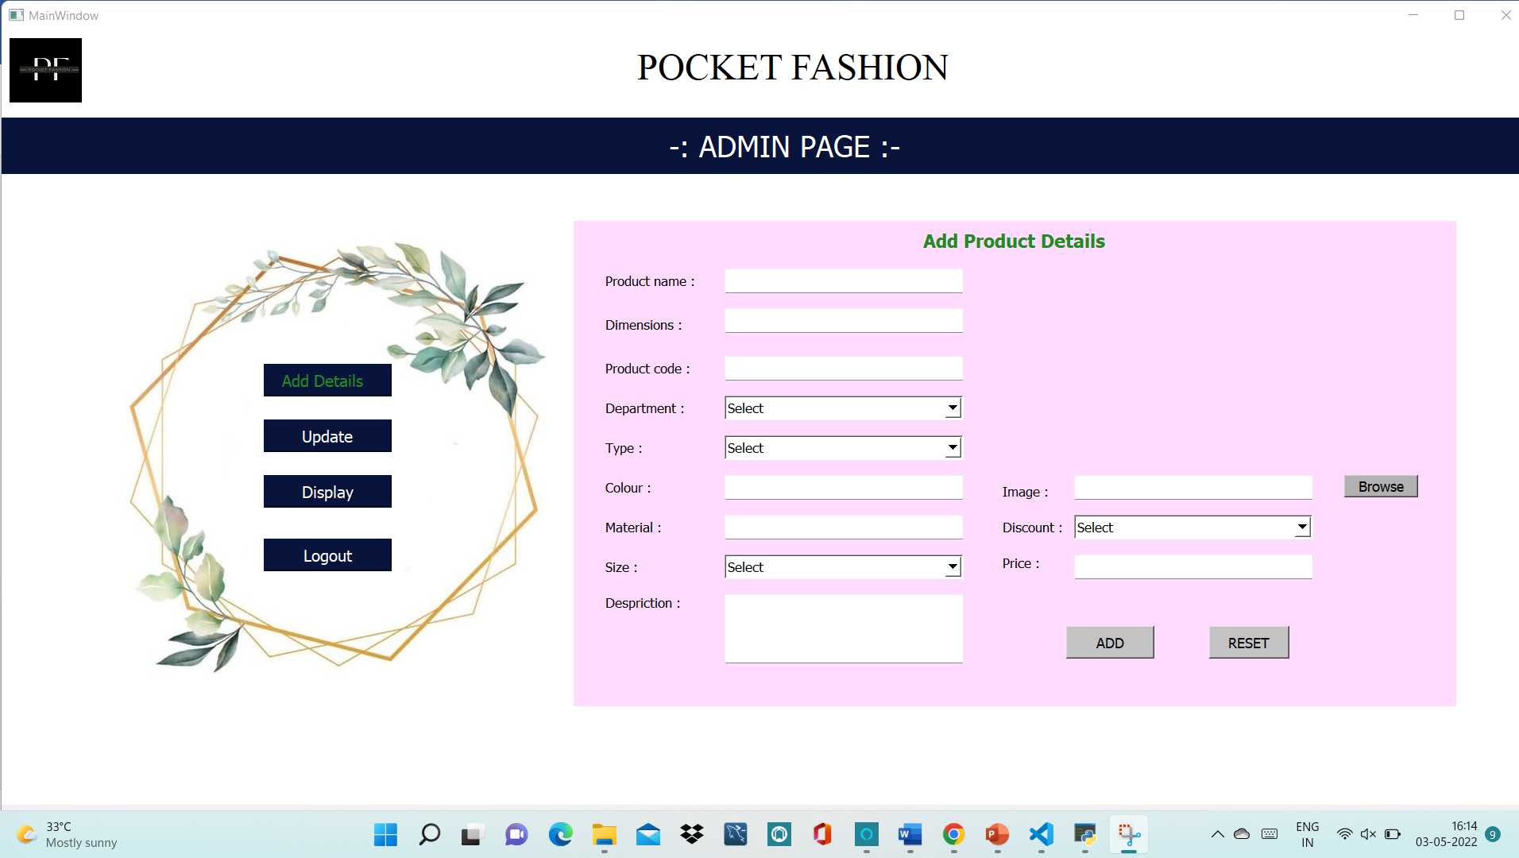

6.1.2. Create product

1. **Update product** : The Admin can update the inserted products using the search button.

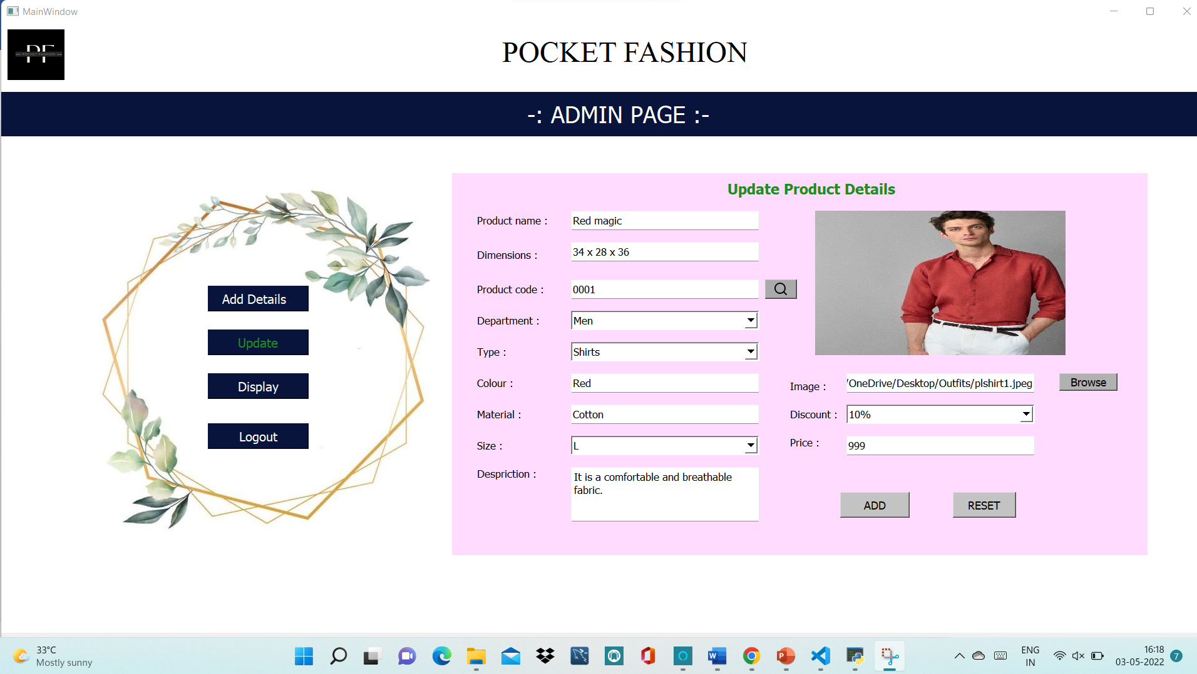

6.1.3. Update products

1. **Display products** : The admin can view all products an also delete any product if needed. Also my clicking on the specific product it can direct to update page.

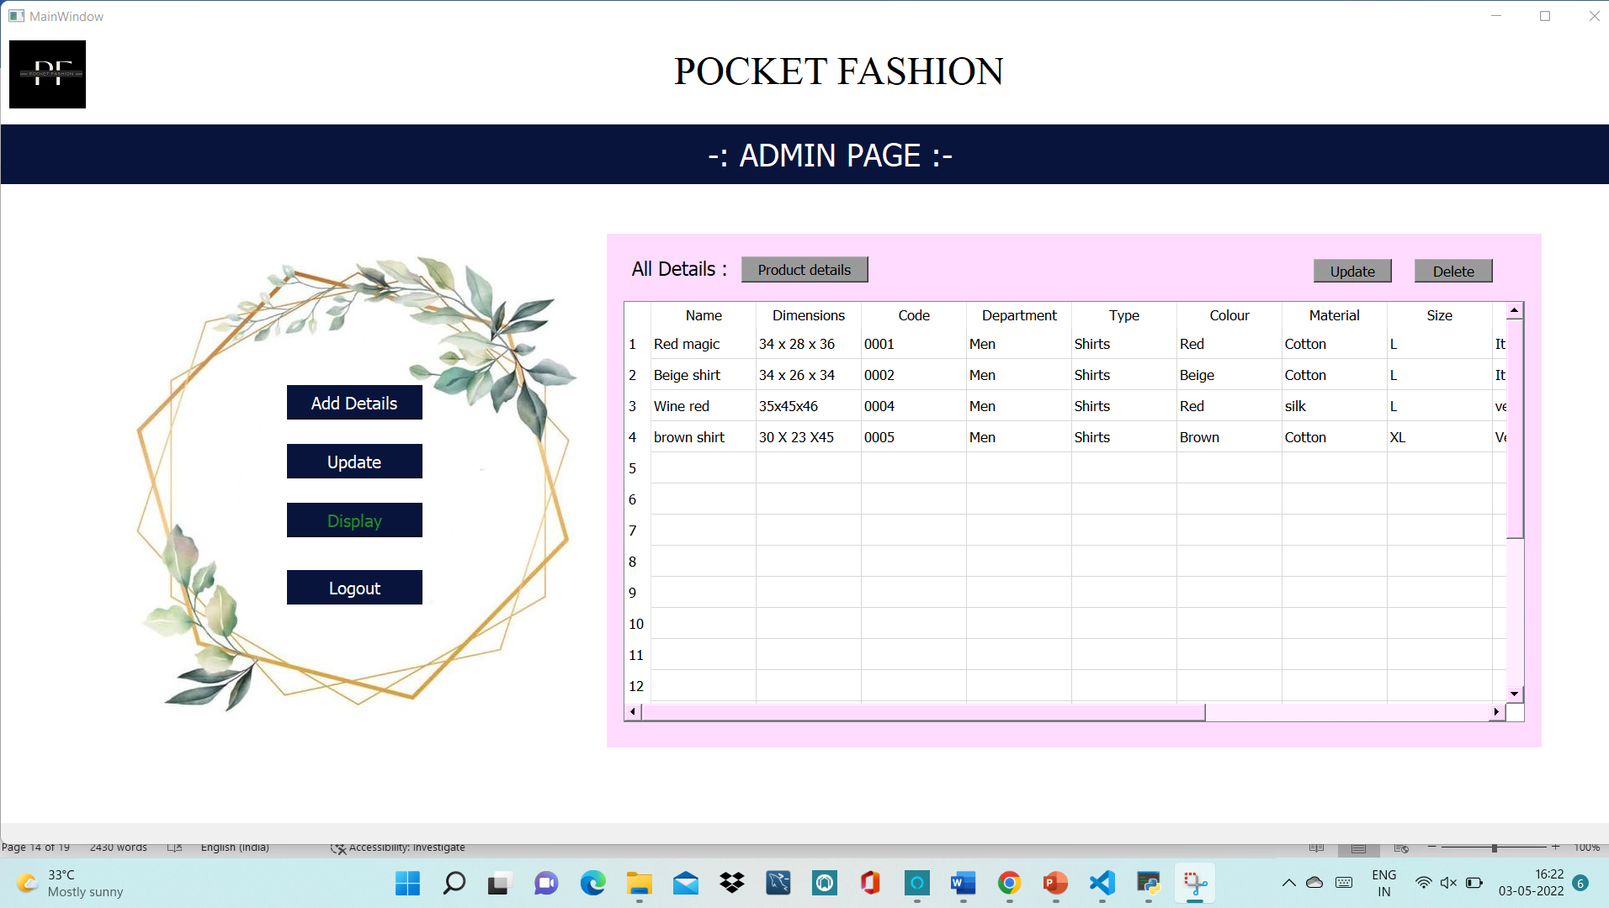

6.1.4. Display products

**Customer page :**

Men’s page :

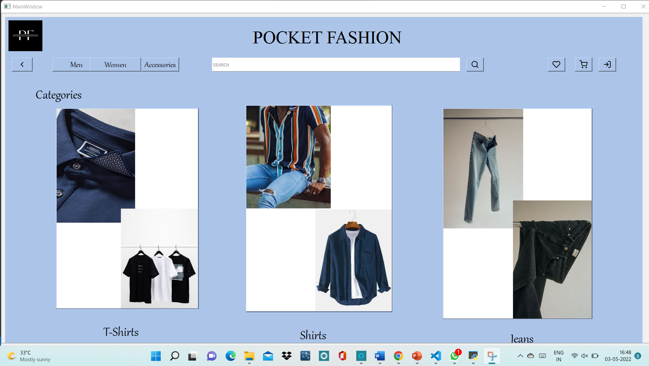

6.1.5. Men’s page

Women’s page :

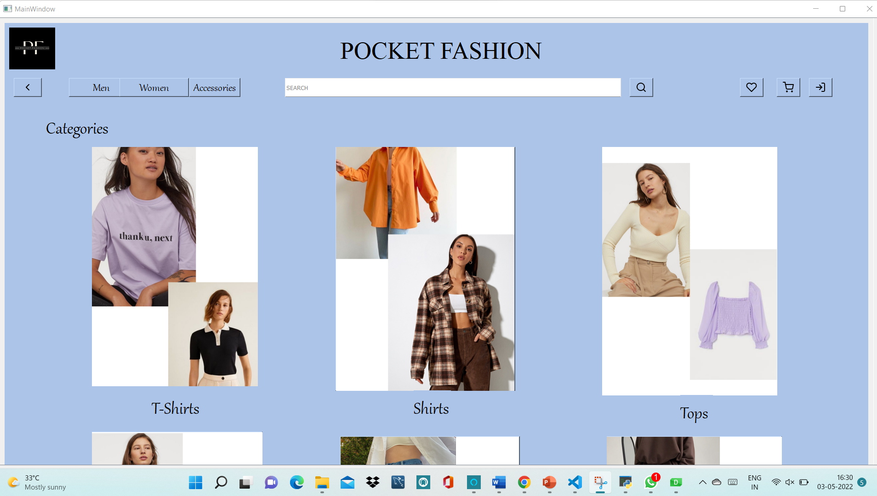

6.1.6. Women’s page

Different subtypes of each category :

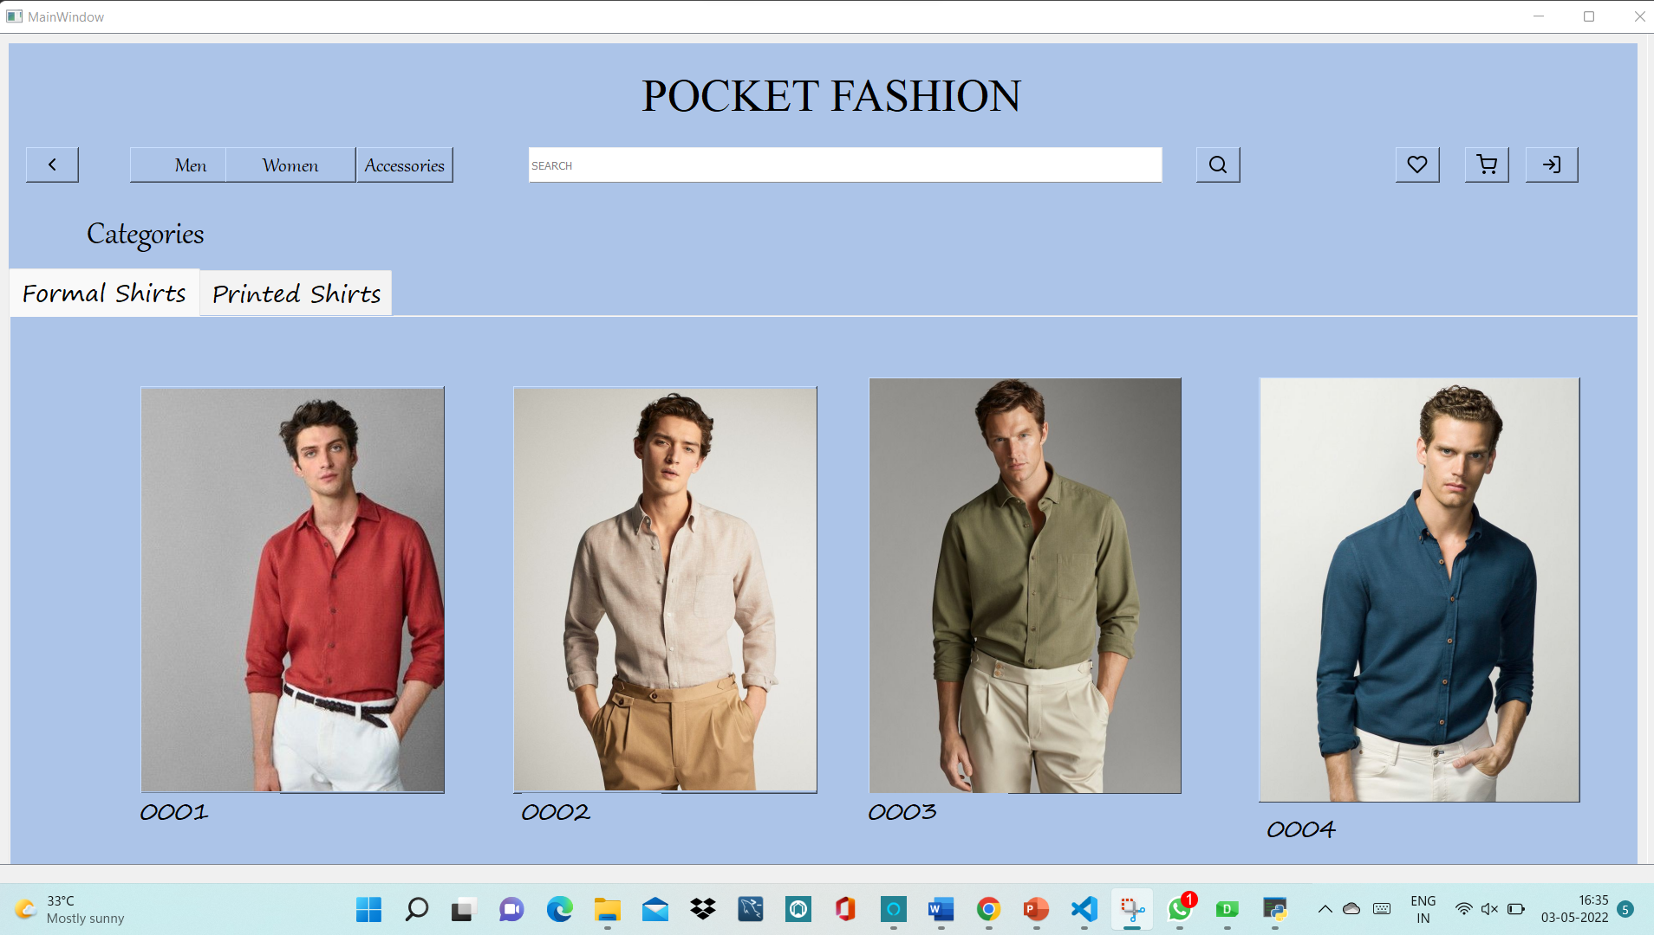

6.1.7. Different subtypes of each category

Display page for product :

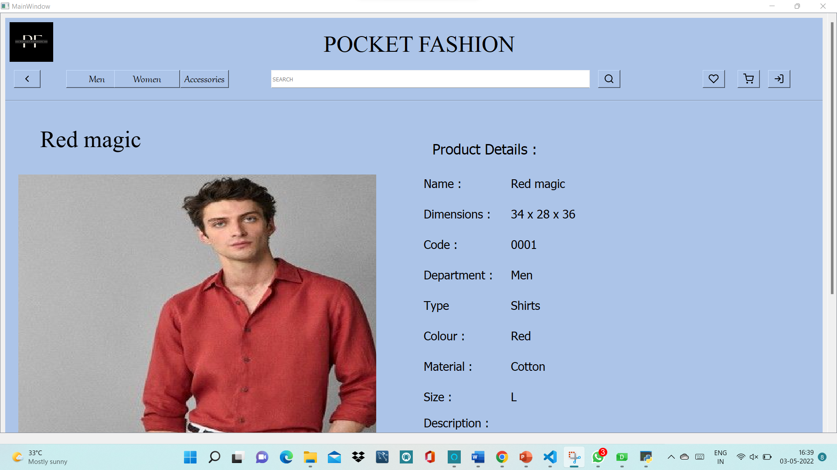

6.1.8. Display page for product

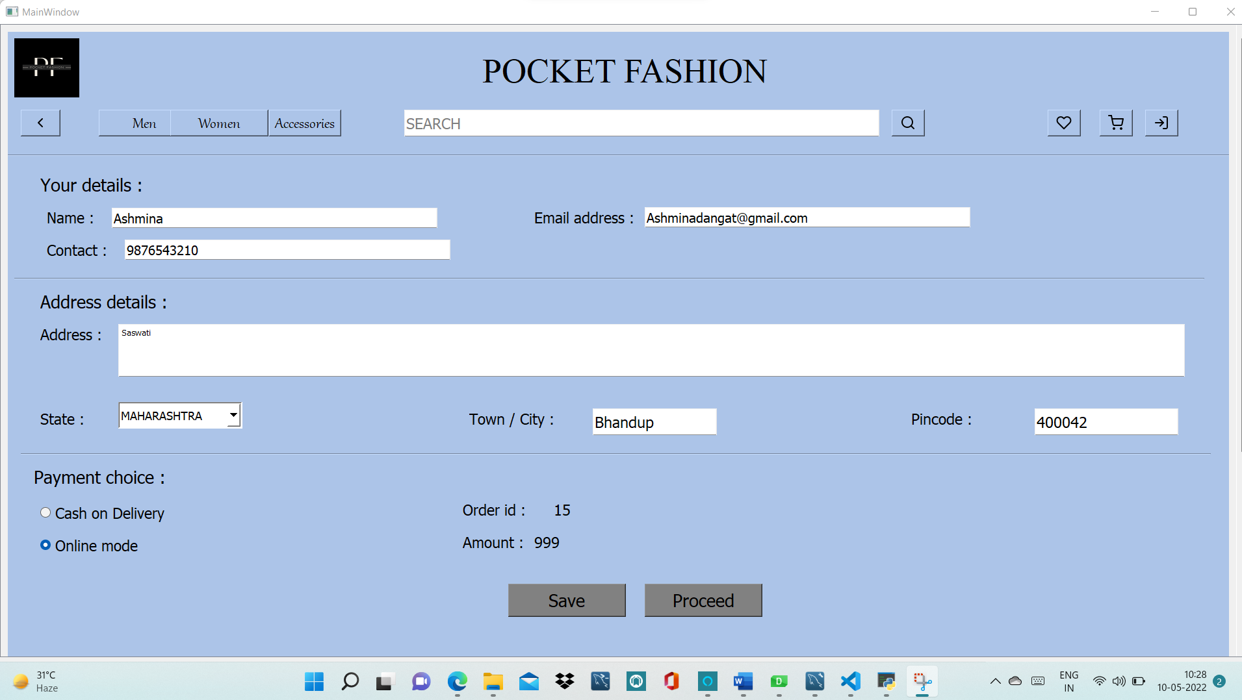

6.1.9. Shipping details

# Chapter 7

**Project Scheduling Template**

|  |  |  |  |  |  |
| --- | --- | --- | --- | --- | --- |
| **Sr.**  **No** | | **Group Member** | | **Time duration** | **Work to be done** |
| **1** | | Ashmina Dangat  Sakshi Gunjal  Neha Chaudhary  Kritika Donde | | 1st week of February To 3nd week of February | Homepage (Designing the Main page for user will login with security verification and will enter to the main menu)  Also looking into database connectivity for Login / Registration of customers. |
| **2** | | Ashmina Dangat  Sakshi Gunjal  Neha Chaudhary  Kritika Donde | | End February to 2nd week of March | Designing next pages of user part where customers can get a segregated view of our clothing products.  Also the functionalities of connecting the pages. |
| **3** | | Ashmina Dangat  Sakshi Gunjal  Neha Chaudhary  Kritika Donde | 3rd week of March to end March | Admin part  Designing the admin login, dashboard of Admin. This will consist of the page where admin will have to enter their id and password to login and access the main menu where there will be options like:  • Insert product  • Update product  • View inserted products |
| **4** | | Ashmina Dangat  Sakshi Gunjal  Neha Chaudhary  Kritika Donde | 1st Week of April to 3rd week of April | Connecting database with the pages for Admin part. Database for product details created and connected.  Also connecting database to display details of products in Customer section. |
| 5 | | Ashmina Dangat  Sakshi Gunjal  Neha Chaudhary  Kritika Donde | 4th Week of April to Start of May | Payment gateway and connecting it to user pages. |

Table 7.1 Project Scheduling Template

# Chapter 8

**Conclusion:**

Before online shopping there was only shopping in store but as the world has got more technology, shopping online has become more popular. I think that as the time goes on soon everyone will shop online, but I think shops will still stay in business because without shops people cant visually see what their buying and people may want their item that exact time when they see it and only by actually going shopping you can have the item you want at the exact same time you purchase it so that’s why I think that online shopping will never take over actual shops on the high street. They could improve online shopping by making the delivery time a lot quicker or allowing people to make a delivery time exactly when they want it.

**At the end it is concluded that we have made effort on following points…**

* A description of the background and context of the project and its relation to work already done in the area.
* Made statement of the aims and objectives of the project.
* The description of Purpose, Scope, and applicability.
* We define the problem on which we are working in the project.
* We describe the requirement Specifications of the system and the actions that can be done on these things.
* We understand the problem domain and produce a model of the system, which describes operations that can be performed on the system.
* We included features and operations in detail, including screen layouts.
* We designed user interface and security issues related to system.
* Finally, the system is implemented and tested according to test cases.

**References**

* Code references : [**https://stackoverflow.com/**](https://stackoverflow.com/)
* Picture reference : [**https://canvas.apps.chrome/**](https://canvas.apps.chrome/)

[**https://in.pinterest.com/**](https://in.pinterest.com/)

* App design references : <https://www.bonkerscorner.com/>

**ACKNOWLEDGEMENT**

This project would not have come to fruition without the invaluable help of our guide **Prof**. **Mansi Choche** . Expressing gratitude towards our HoD, **Prof. Kiran Deshpande**, and the Department of Information Technology for providing us with the opportunity as well as the support required to pursue this project. We would also like to thank our teacher **Prof. Anagha Aher** who gave us her valuable suggestions and ideas when we were in need of them. We would also like to thank our peers for their helpful suggestions.